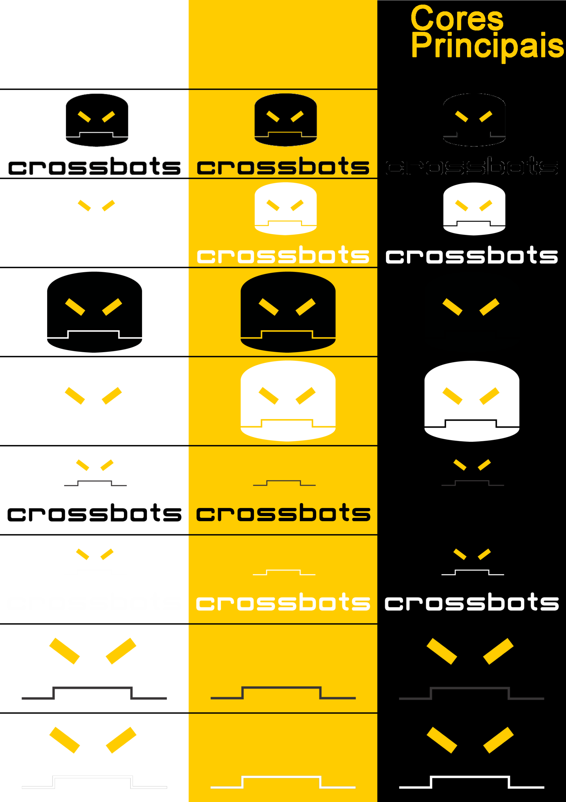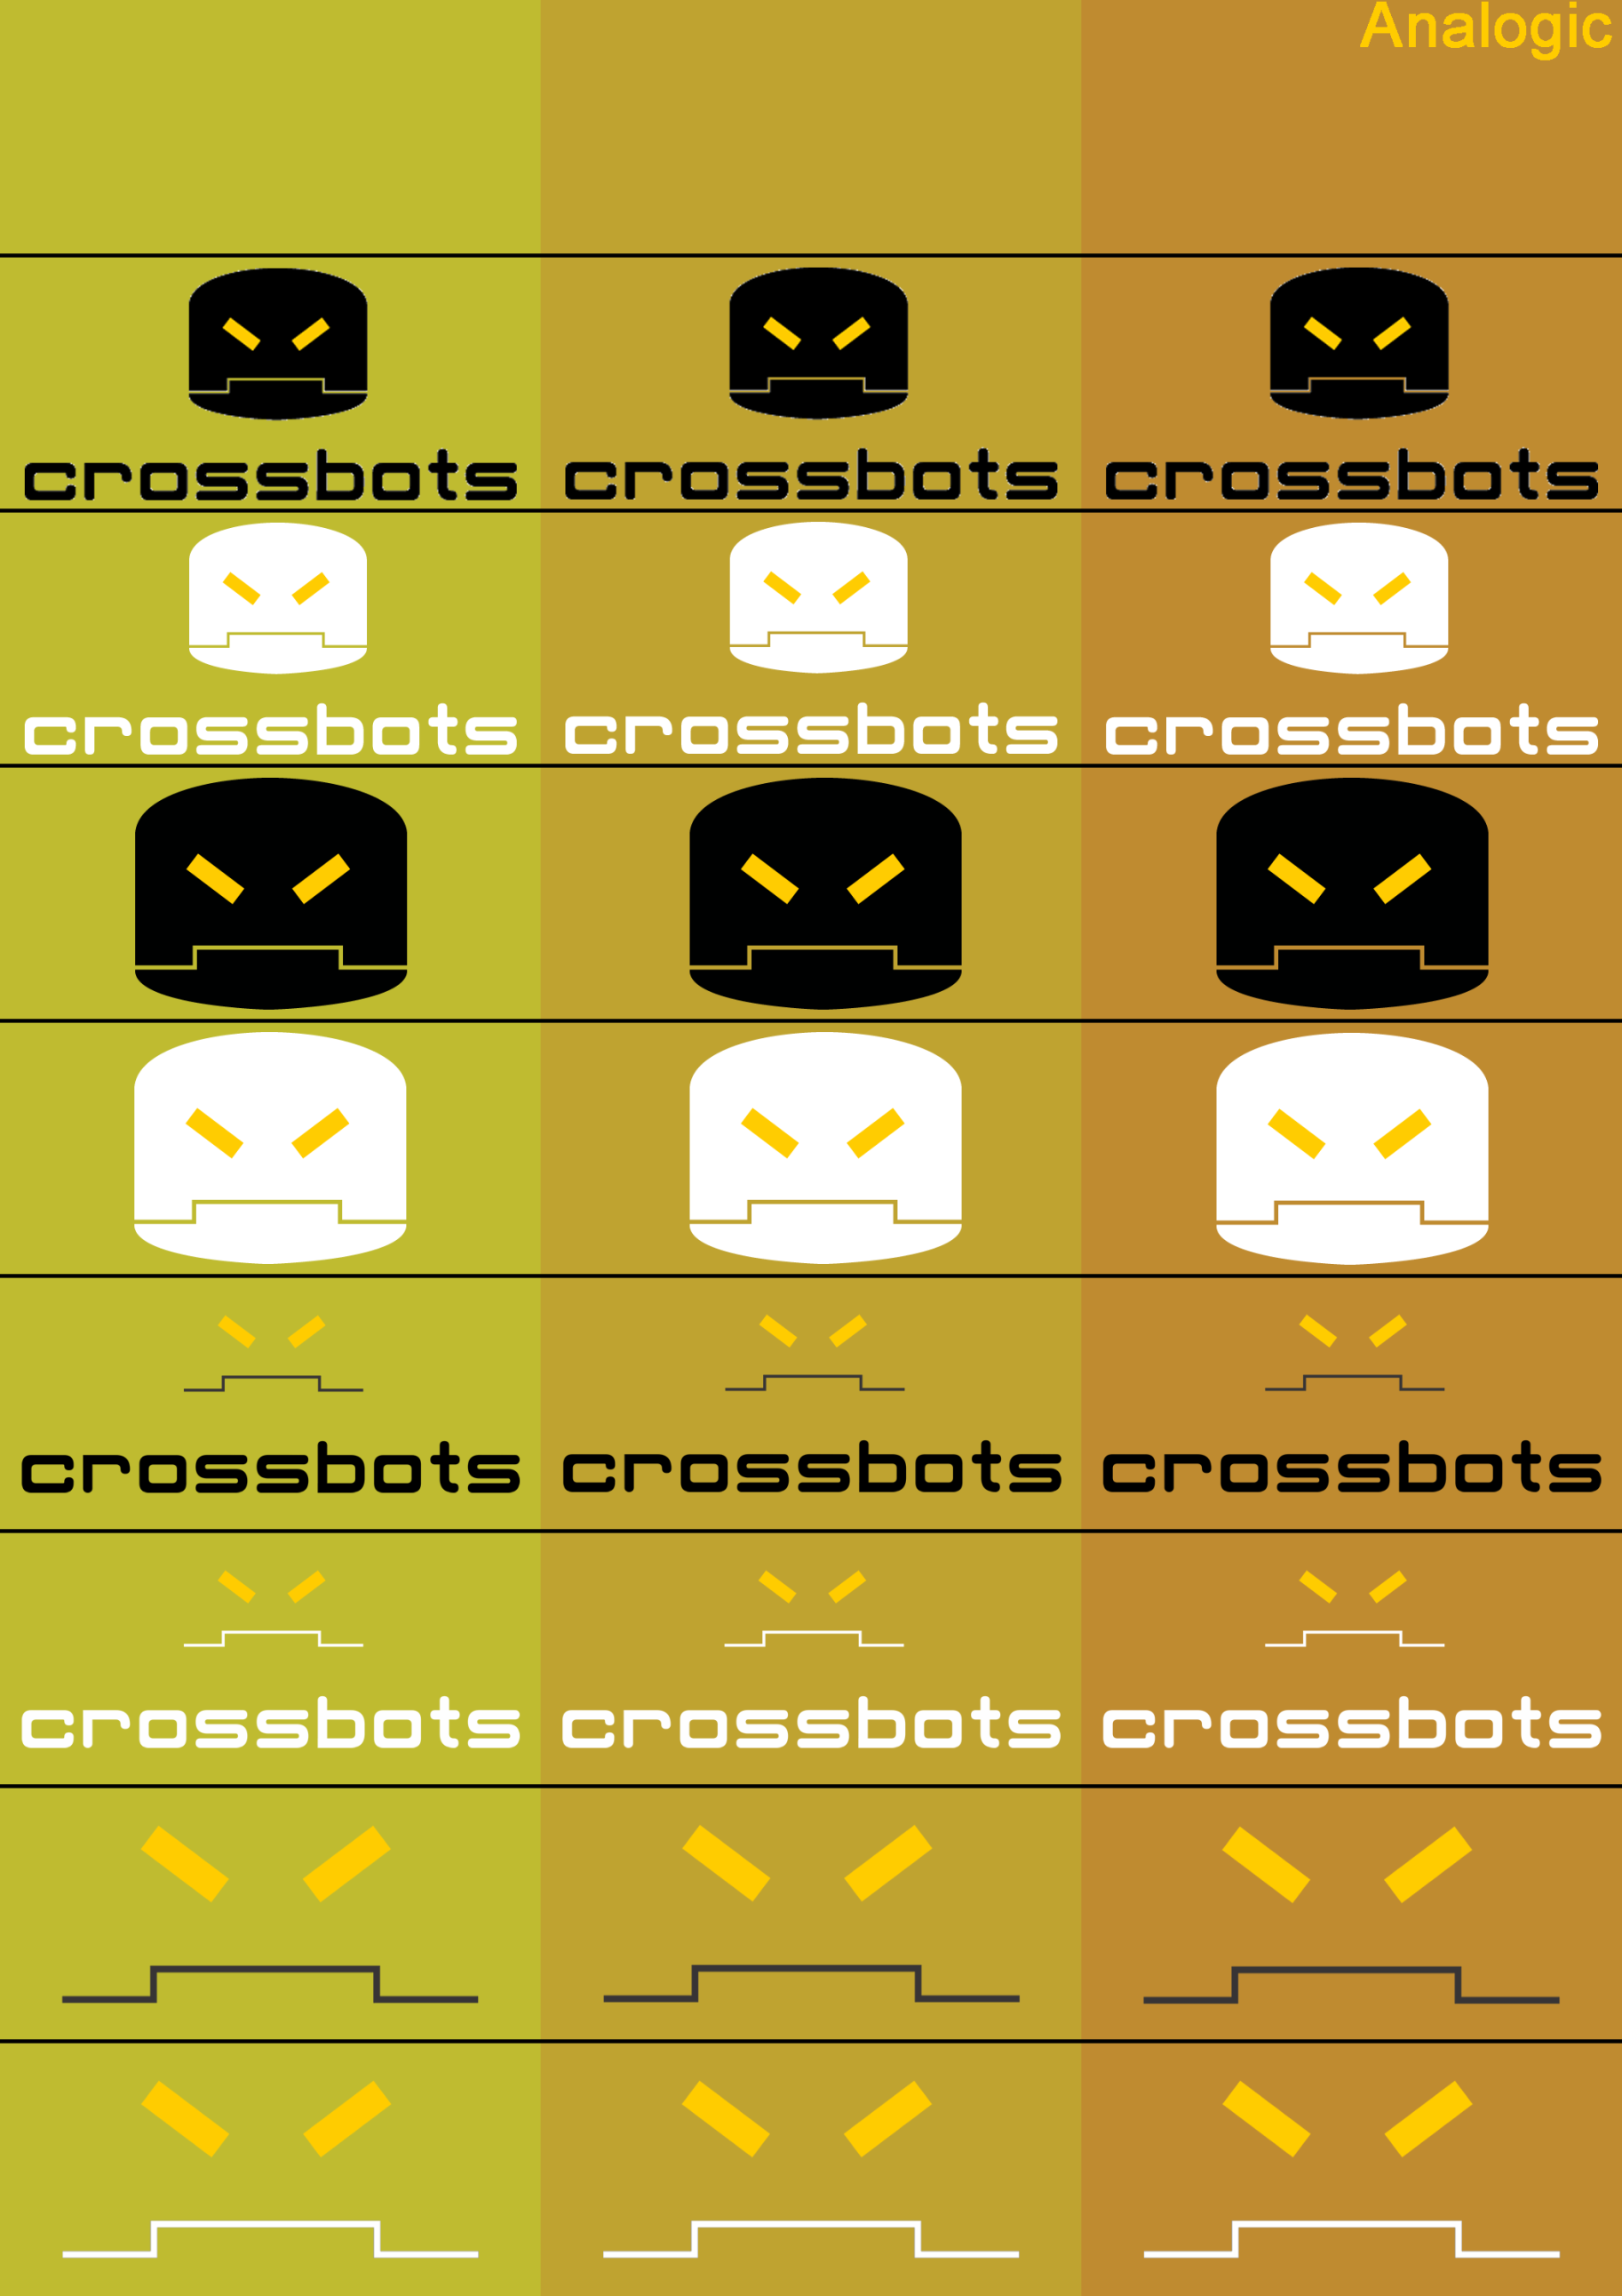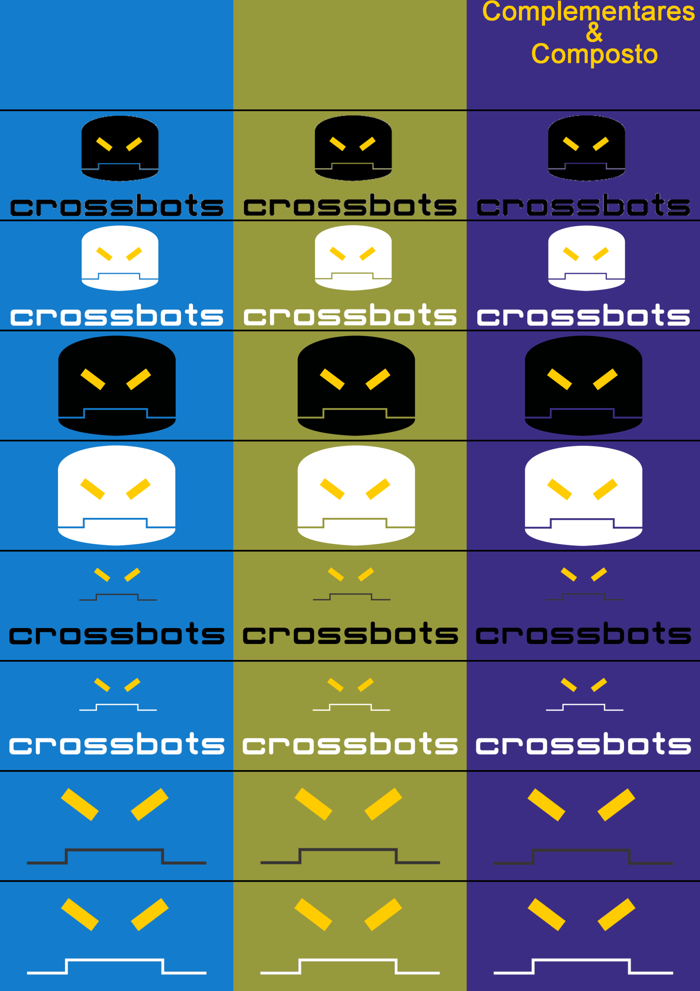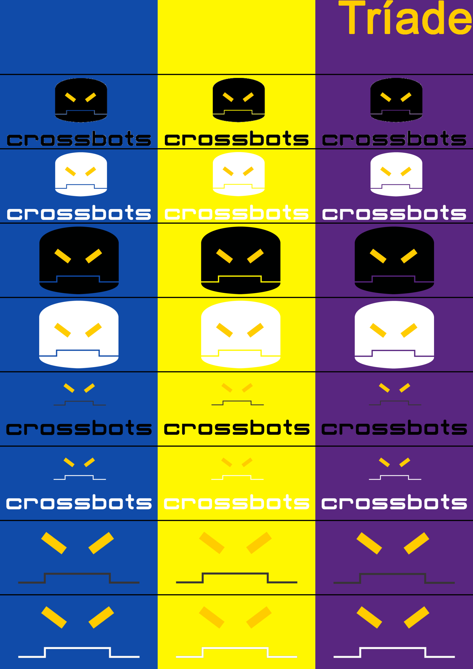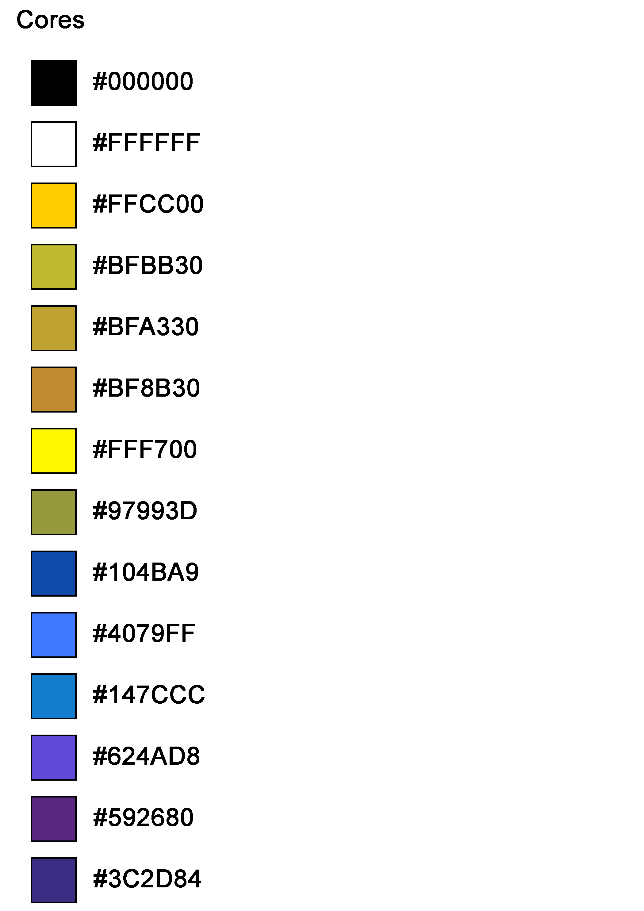

Fontes

Arial Black

Poplar Std

Adobe Fan Heiti Std B

Arial

Calibri

Helvetica

Verdana

Napalm Vertigo

Stencil STD

Bank Gotic LT BT

LCD

Arcade Classic

Karmatic Arcade

